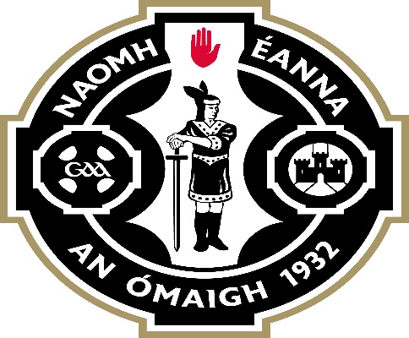

CRUINNIÚ BLIANTÚIL 2024

(Annual General Meeting)

AINMIÚCHÁIN
(Nominations)

(To be returned on, or before, (insert date)

Oifig/Officership/Position: | Ainmniúcháin/Nominee:

Cathaoirleach/Chairperson
Leas-Chathaoirleach/Vice-chairperson
An Rúnaí/Secretary
An Rúnaí Cúnta/Assistant-Secretary
An Cisteoir/Treasurer
An Cisteoir Cúnta/Assistant-Treasurer
Cláraitheoir / Registrar
C.P.O / P.R.O.
Ionadaí na nImeoirí/Players Representative (4 codes)
Oifigeach Gaeilge agus Cultúr/ Language & Culture Officer | Appointed on the recommendation of the outgoing Executive Committee - not an elected position
Oifigeach na Leanaí/Children’s Officer | Appointed on the recommendation of the outgoing Executive Committee – not an elected position
Oifigeach Oiliúna/Coaching Officer
Oifigieach na n’Óg/Youth Officer
Coiste Chontae/County Committee
Oifigeach Peil/Football Officer
Oifigeach Iomana/Hurling Officer
Oifigeach Peil na mBan/Ladies Football Officer
Oifigeach Camogaiocht/Camogie Officer
Oifigeach Slamsa/Entertainment Officer
Oifigeach Forbartha/Development Officer | Appointed on the recommendation of the outgoing Executive Committee – not an elected position

Sínithe/Signed: ___________________________________

Ainm/Name

